BANKING SYSTEM

Tasks 1: Database Design

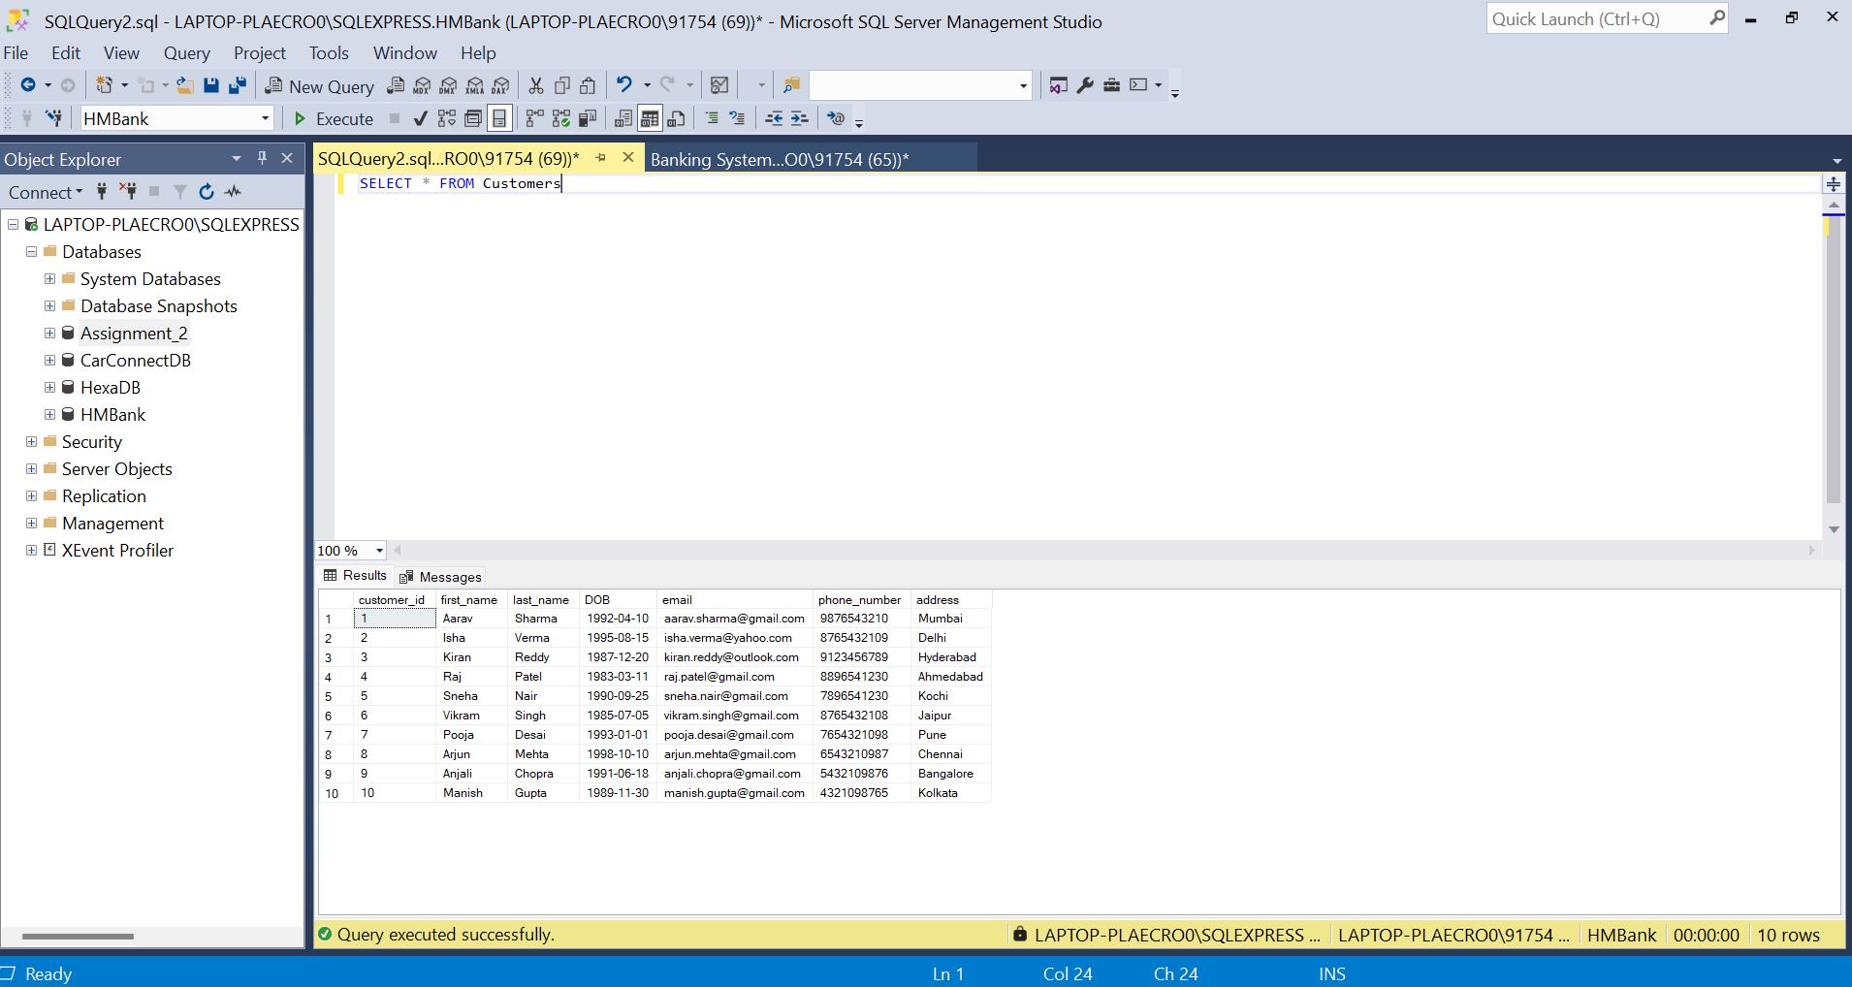

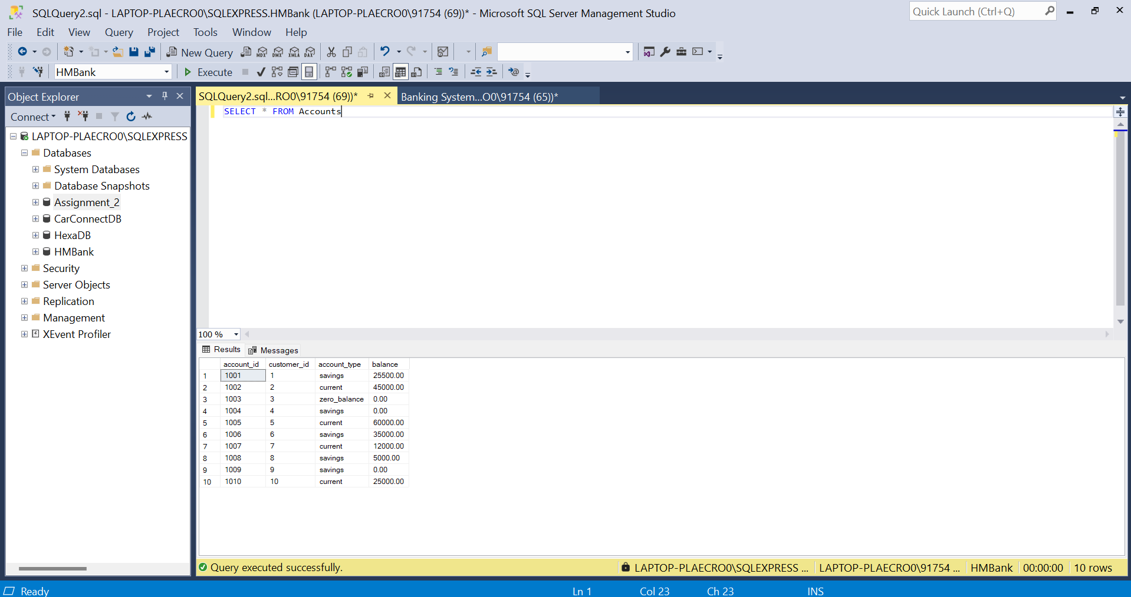

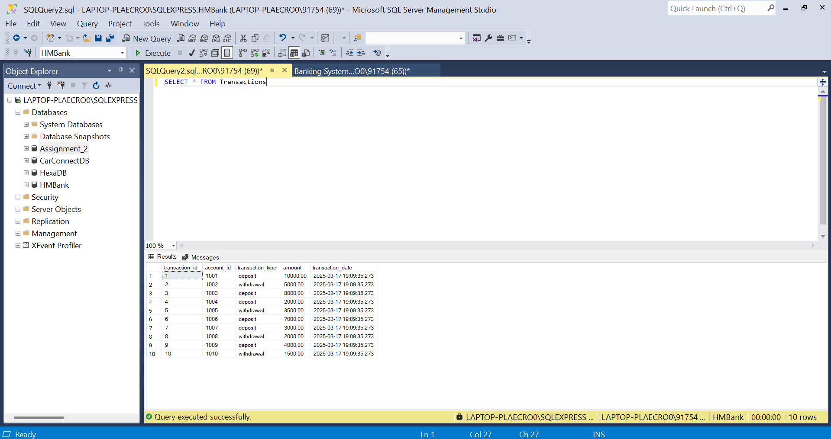

ER Diagram

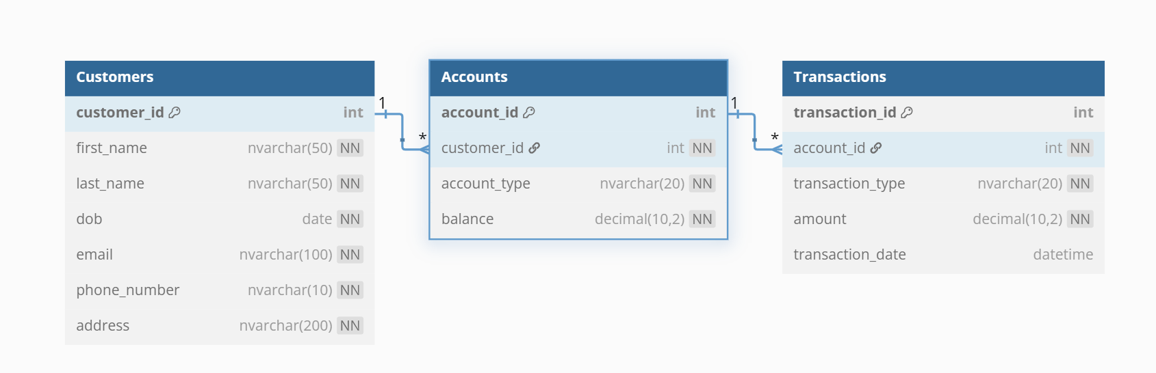

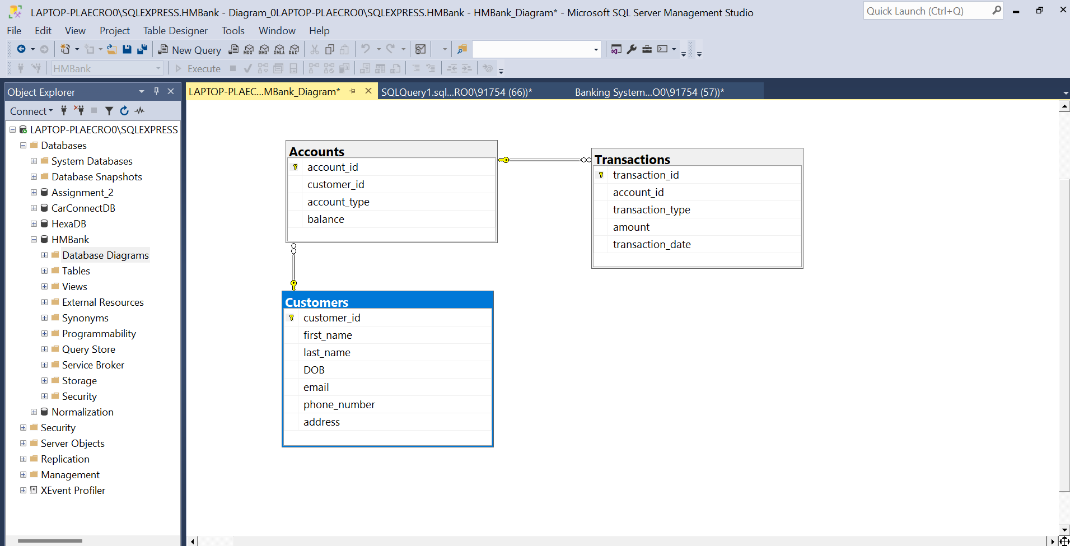

Tasks 2: Select, Where, Between, AND, LIKE

Q1. Name, Account type and email of all Customer

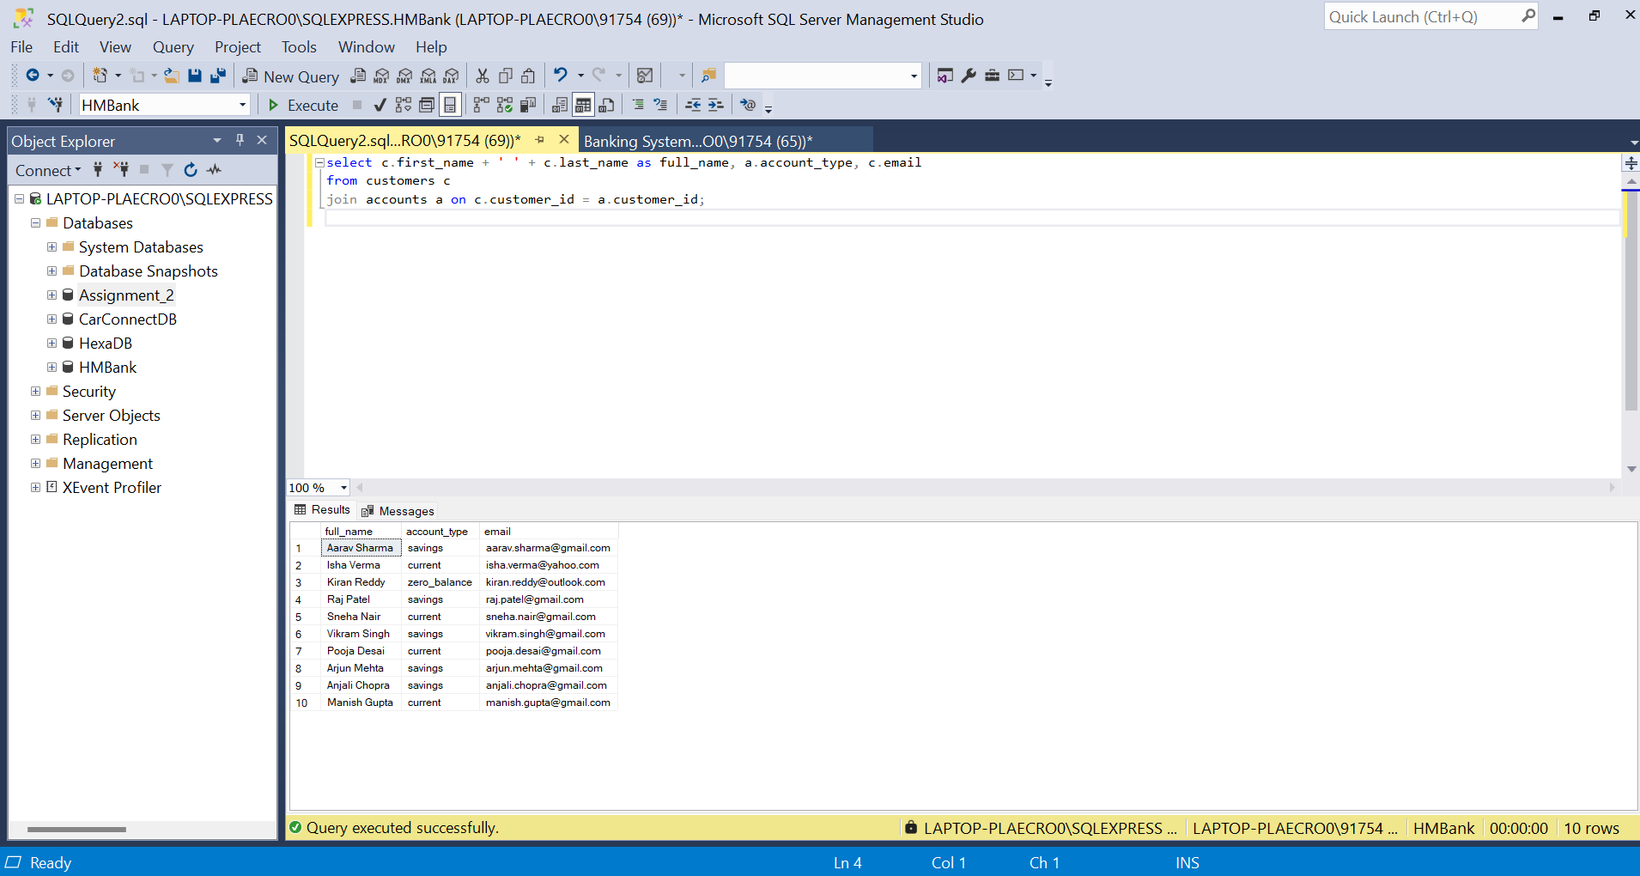

Q2. List All Transactions Corresponding to corresponding Customer

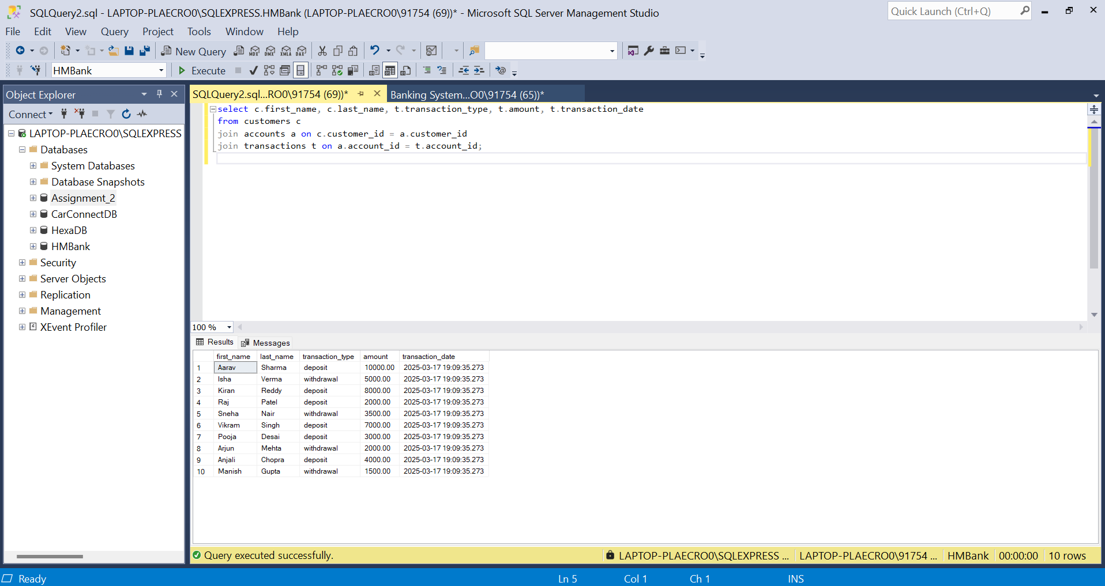

Q3. Increase the Balance of a Specific Account

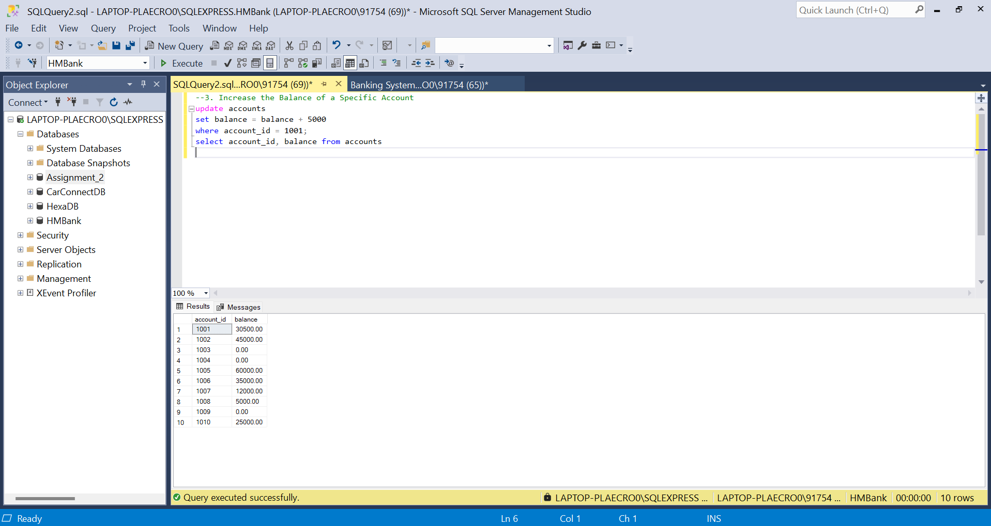

Q4. Combine First and Last Names of Customers as full_name

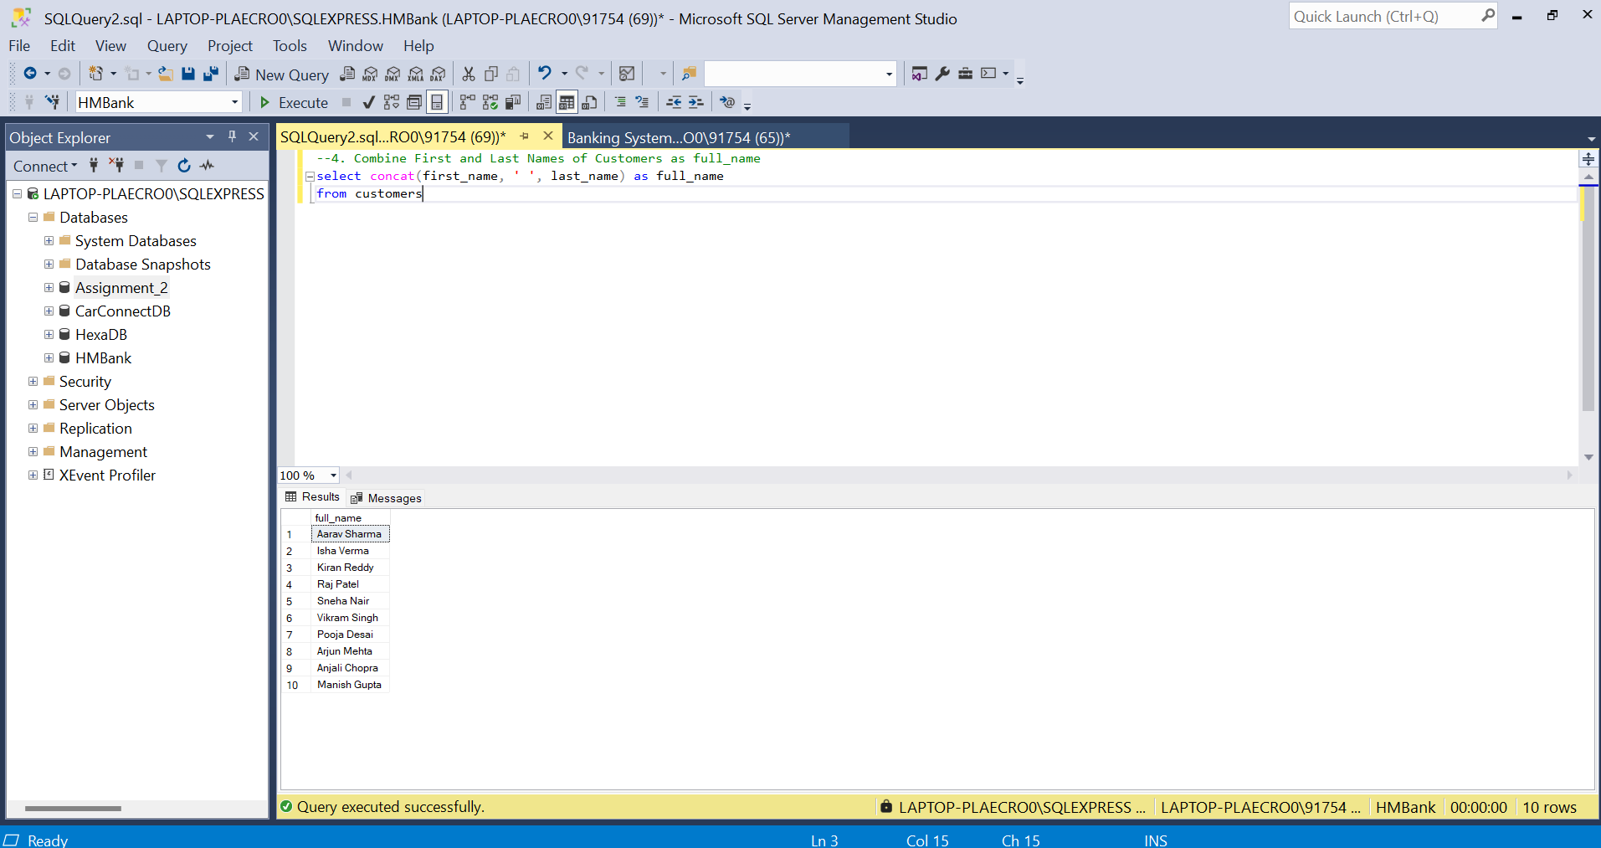

Q5. Remove Accounts with Zero Balance Where Account Type is 'Savings'

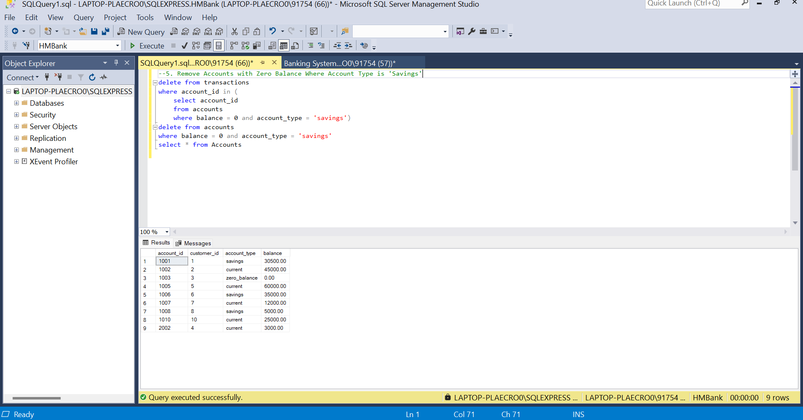

Q6. Find Customers Living in a Specific City

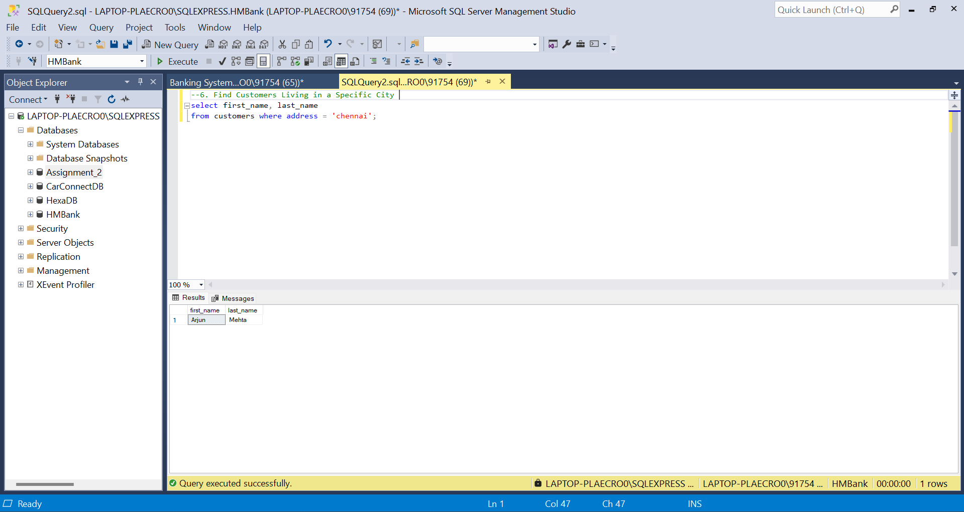

Q7. Get the Account Balance for a Specific Account

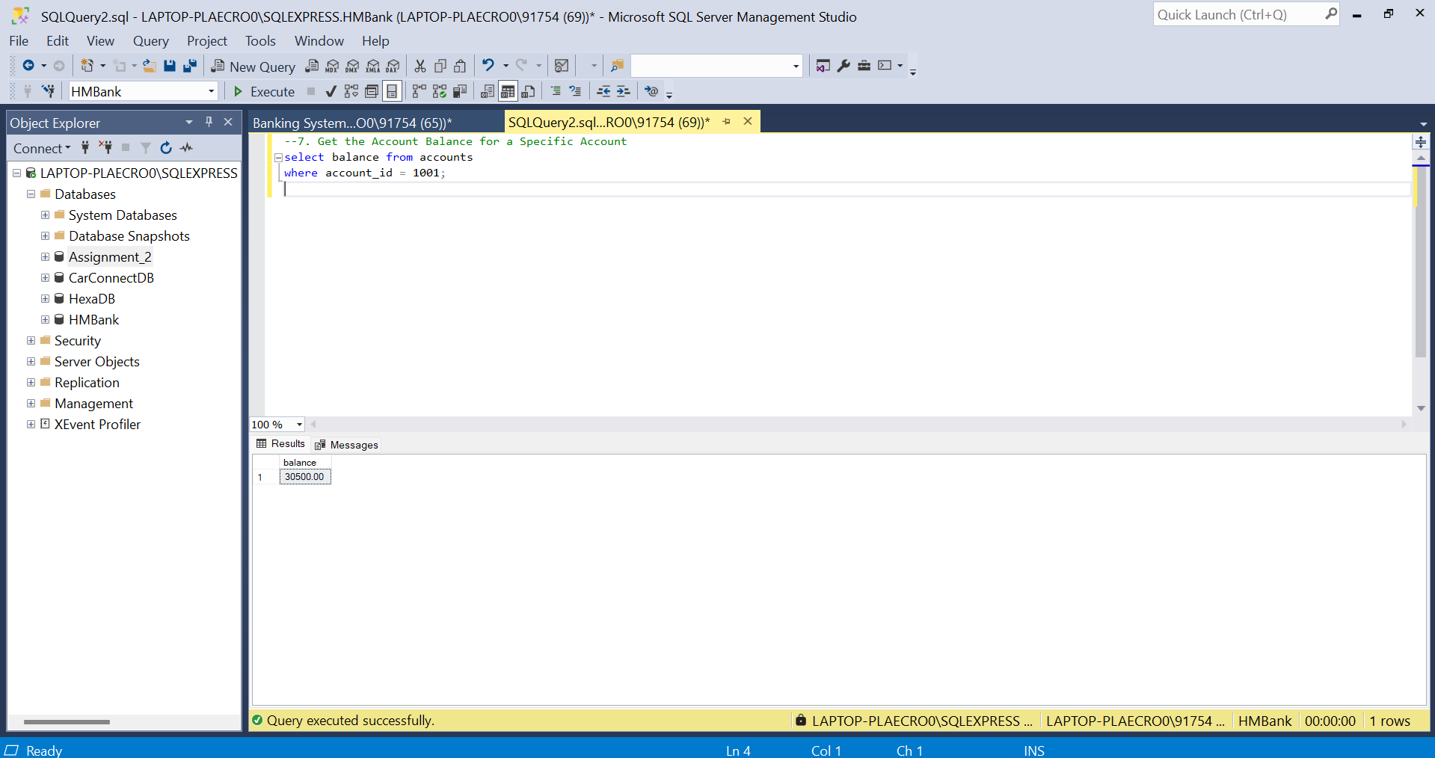

Q8. List All Current Accounts with a Balance Greater Than $1,000

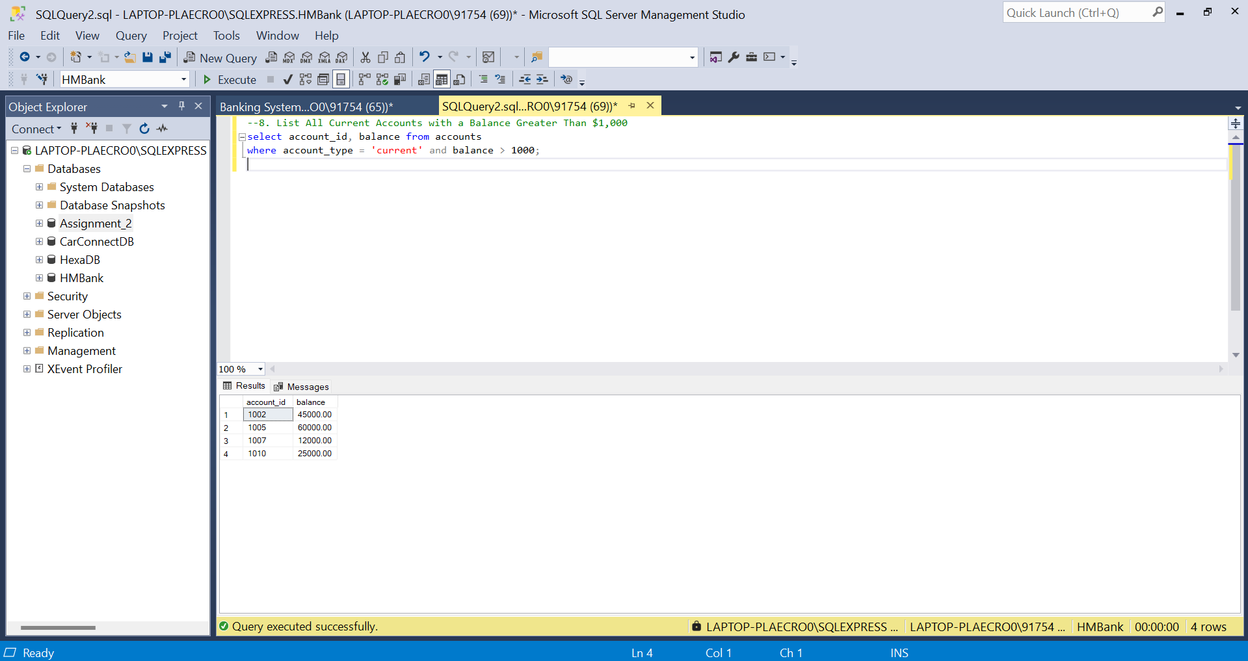

Q9. Retrieve All Transactions for a Specific Account

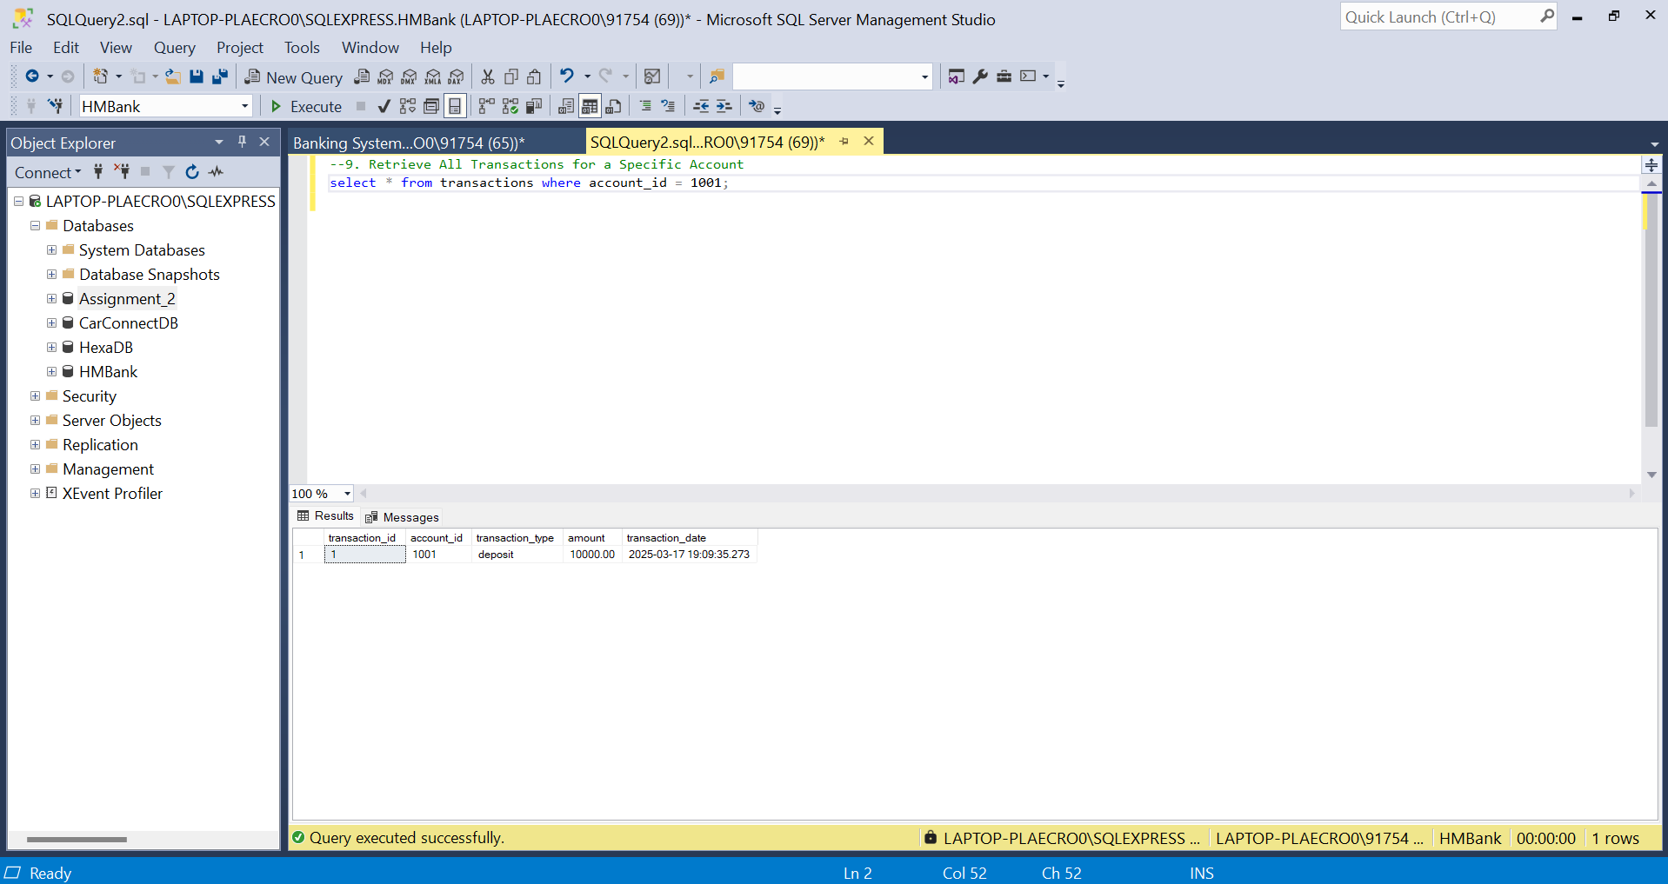

Q10. Calculate Interest Accrued on Savings Accounts

(Interest Rate: 4.5%)

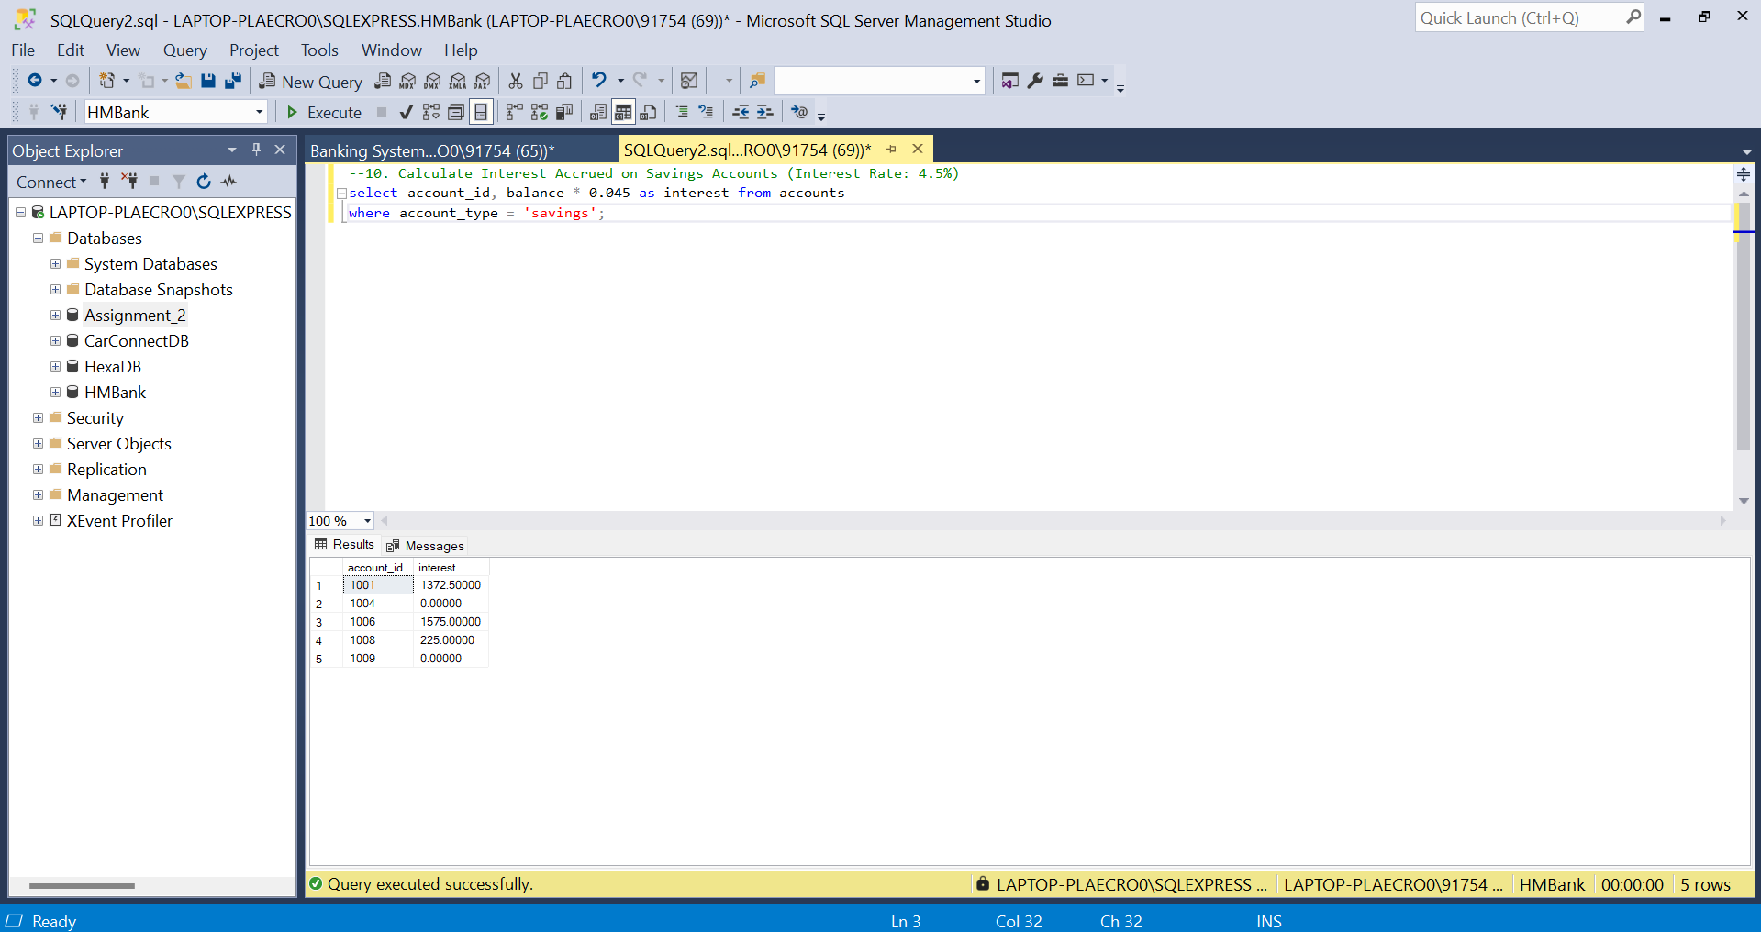

Q11. Identify Accounts Where Balance is Less Than a Specified Overdraft Limit

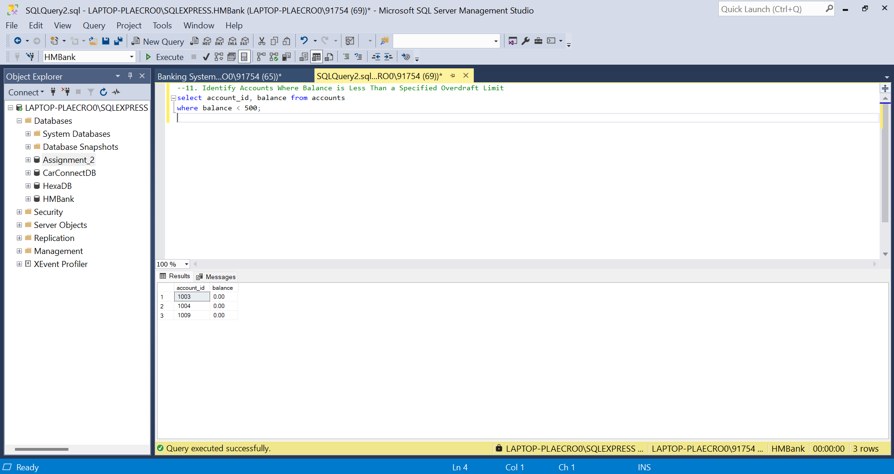

Q12. Find Customers Not Living in a Specific City

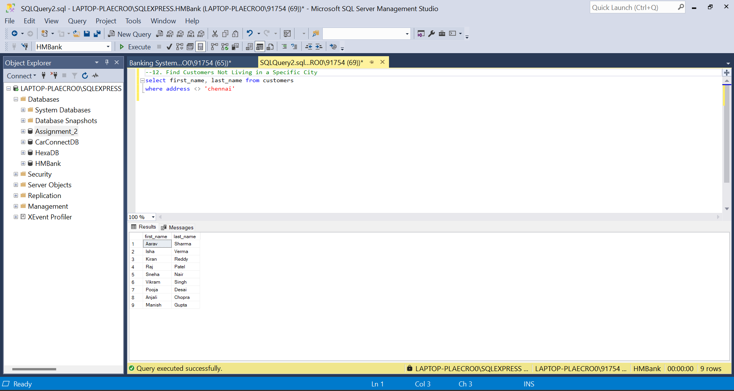

Tasks 3: Aggregate functions, Having, Order By, GroupBy and Joins

Q1. Find the Average Account Balance for All Customers

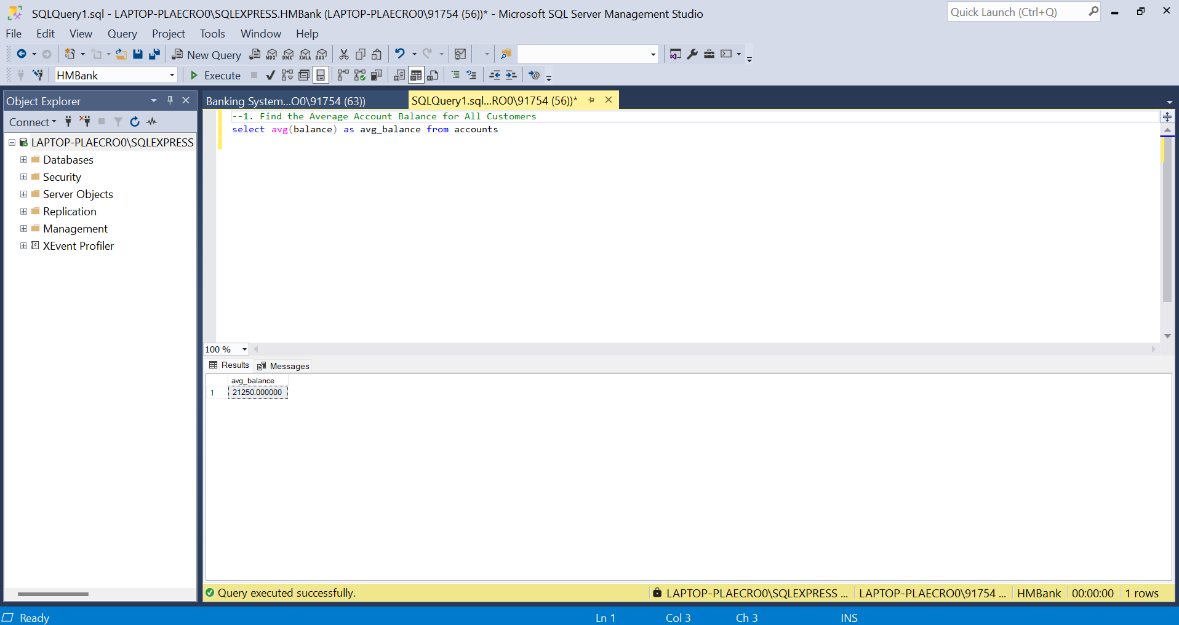

Q2. Retrieve the Top 10 Highest Account Balances

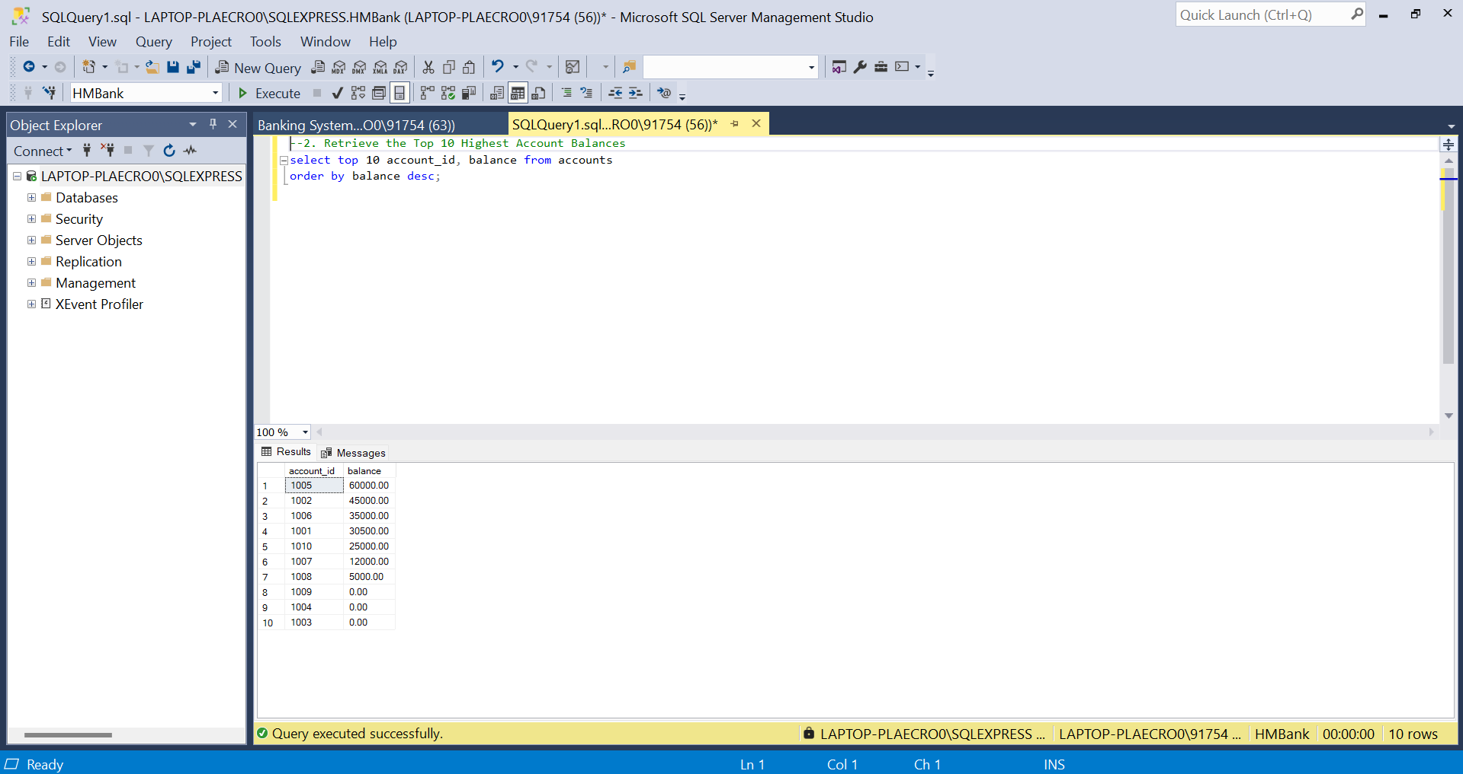

Q3. Calculate Total Deposits for All Customers on a Specific Date

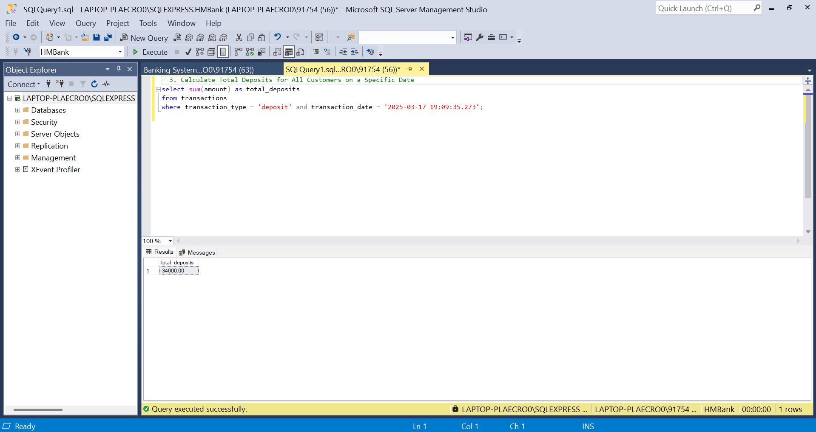

Q4. Find the Oldest and Newest Customers

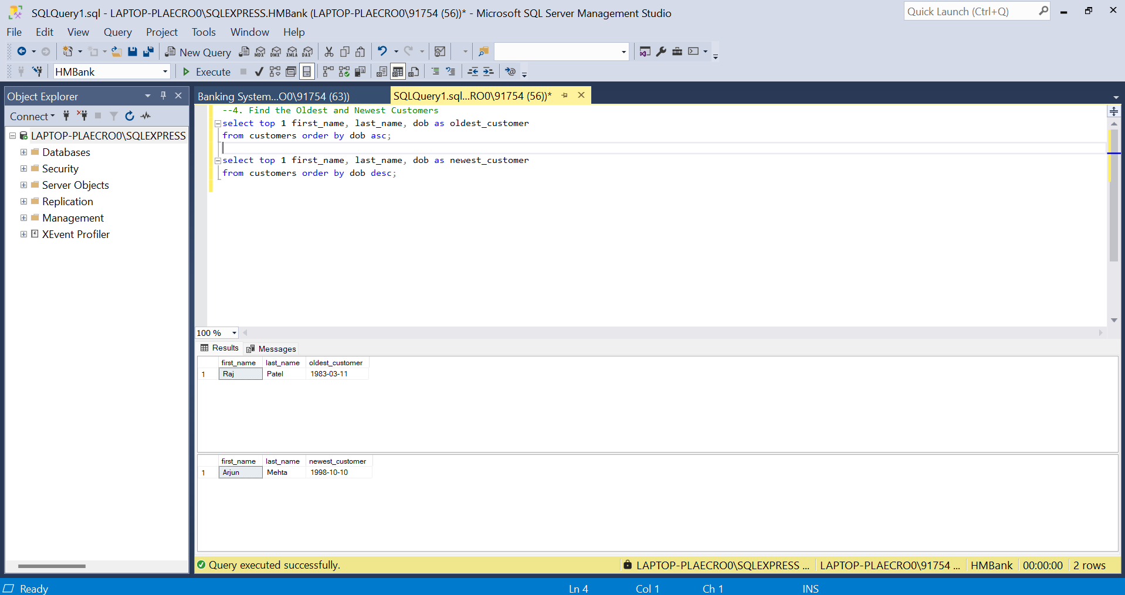

Q5. Retrieve Transaction Details Along with Account Type

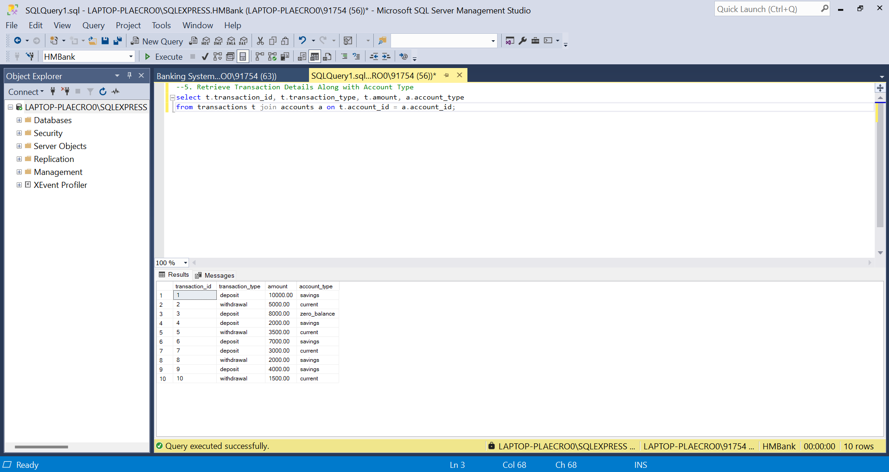

Q6. Get a List of Customers Along with Their Account Details

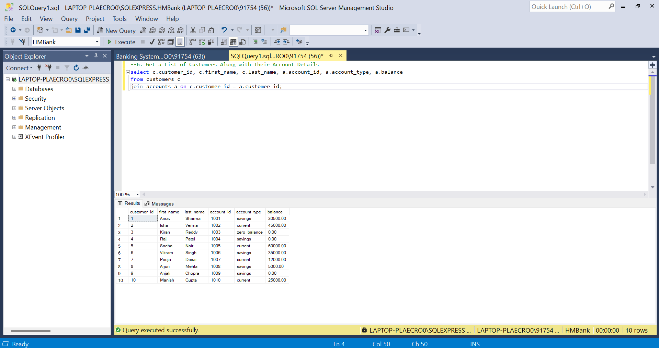

Q7. Retrieve Transaction Details Along with Customer Information for a Specific Account

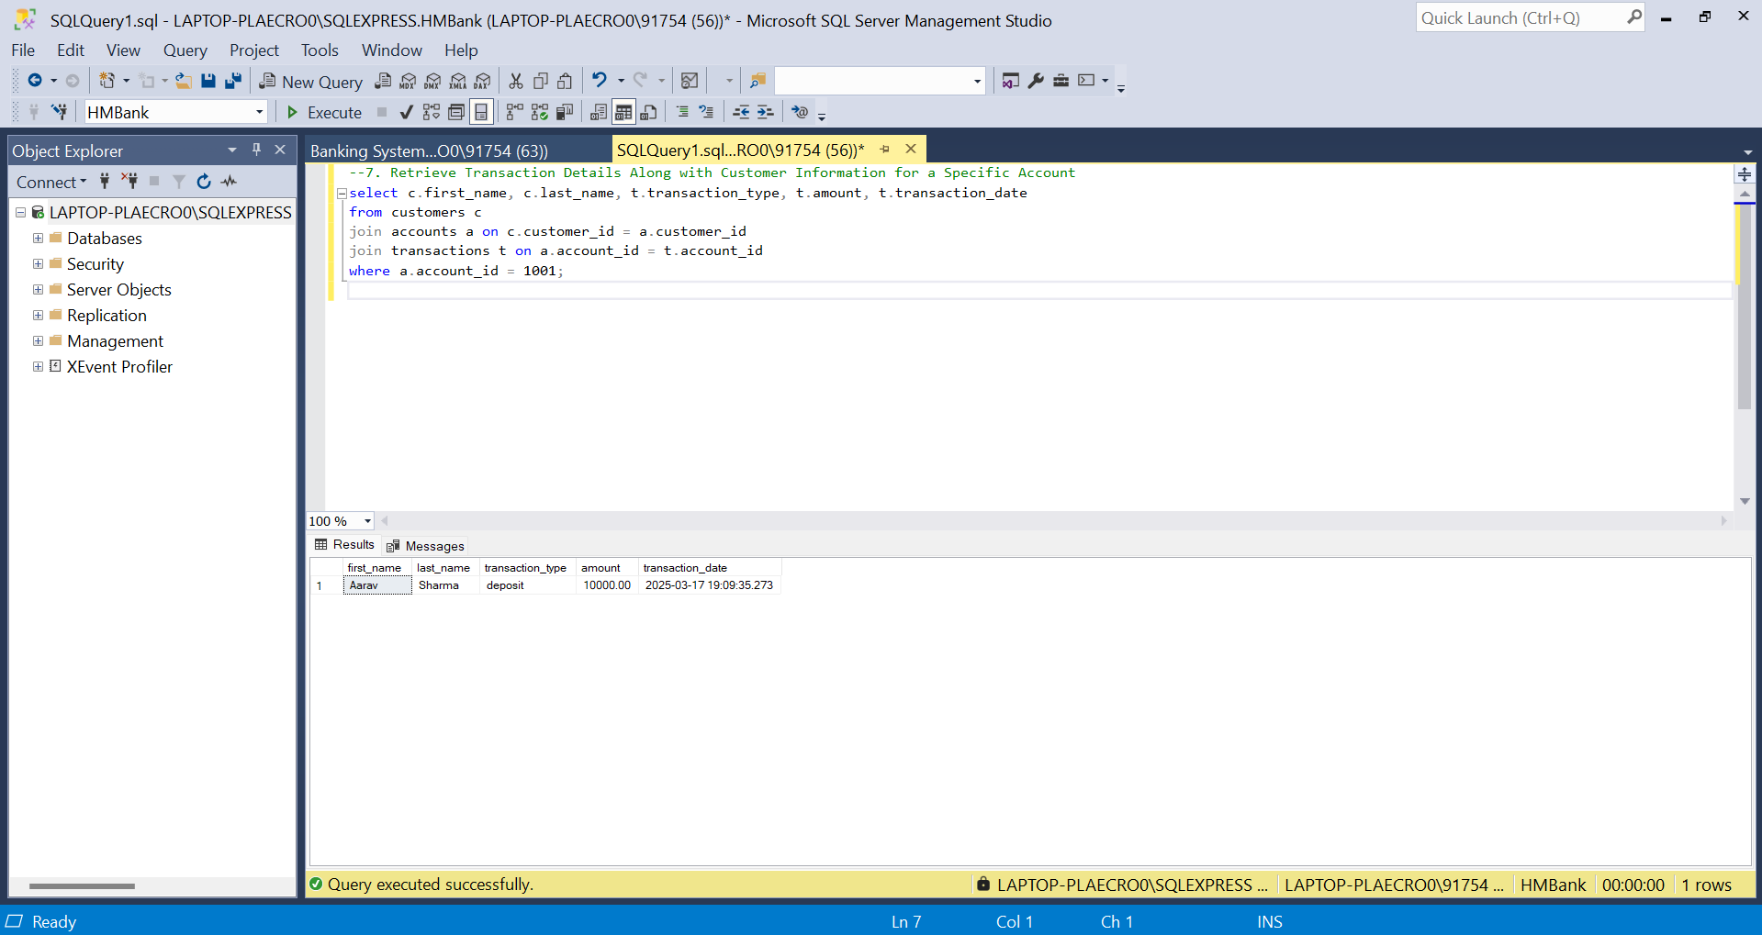

Q8. Identify Customers Who Have More Than One Account

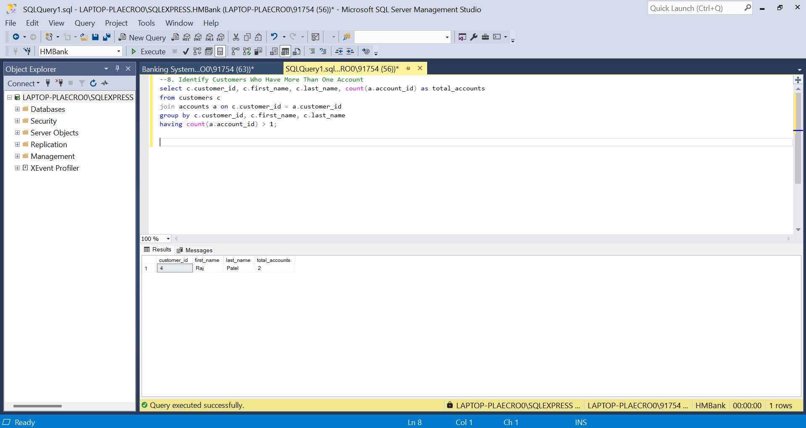

Q9. Calculate the Difference in Transaction Amounts Between Deposits and Withdrawals

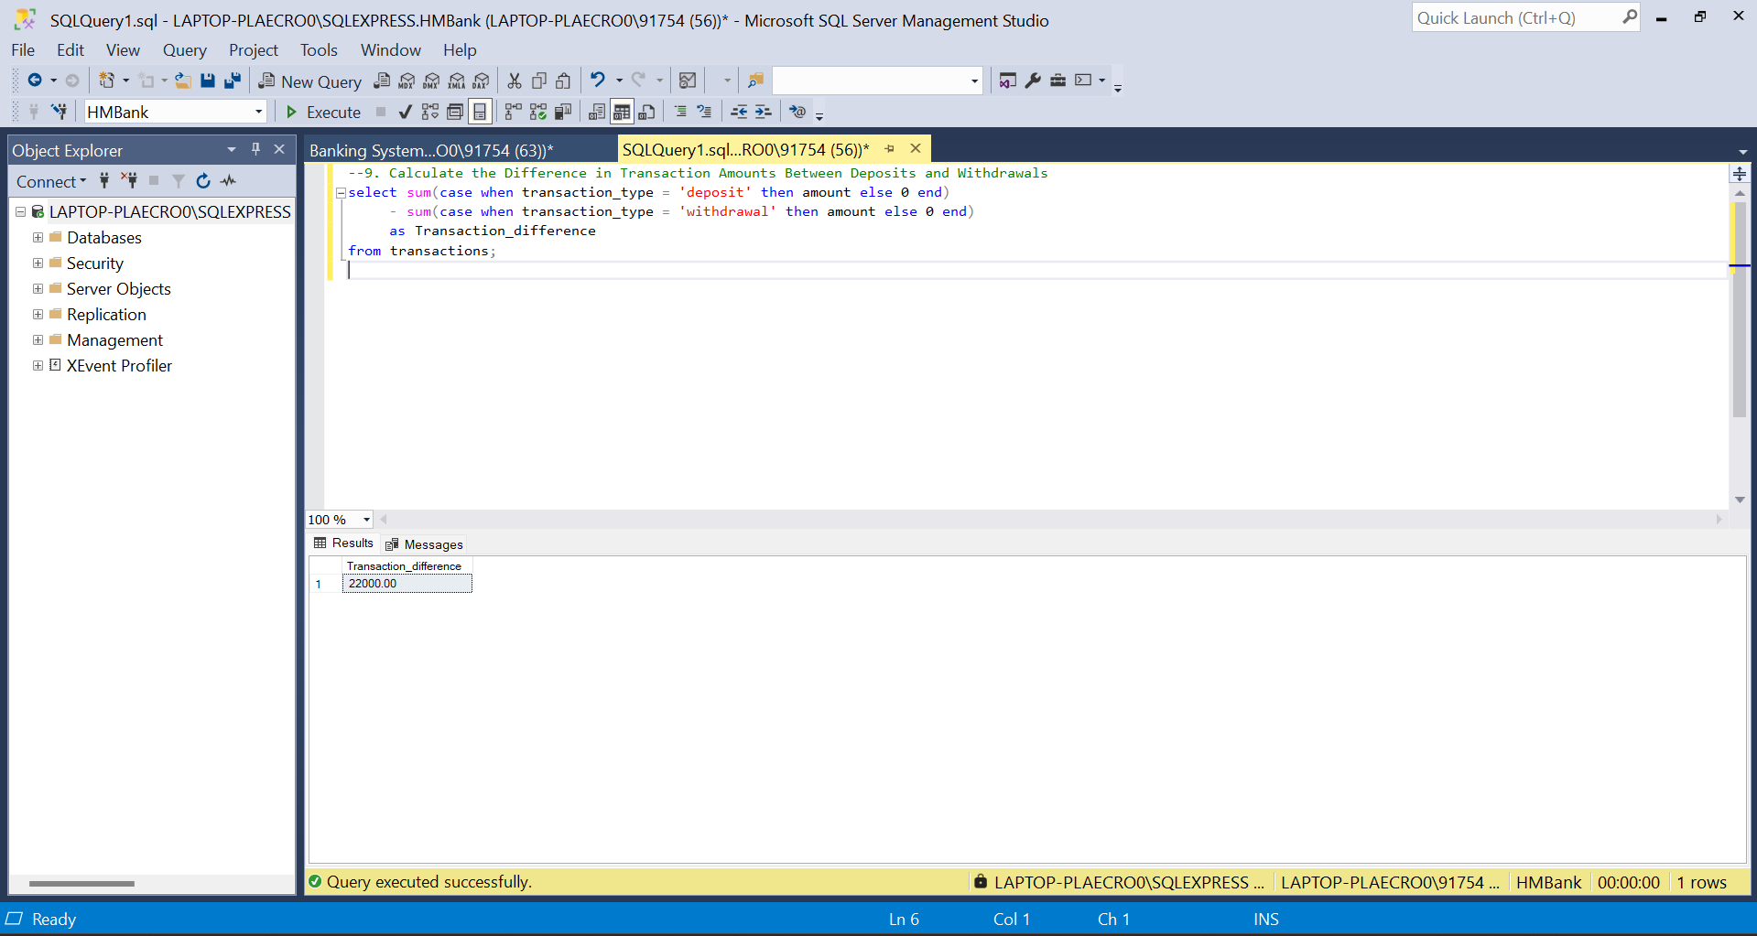

Q10. Calculate the Average Daily Balance for Each Account Over a Specified Period

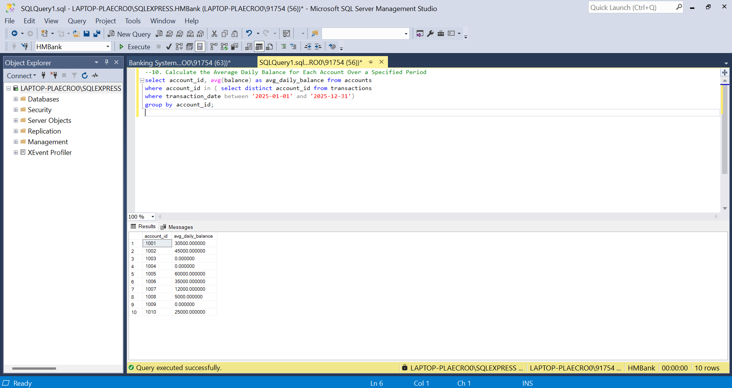

Q11. Calculate the Total Balance for Each Account Type

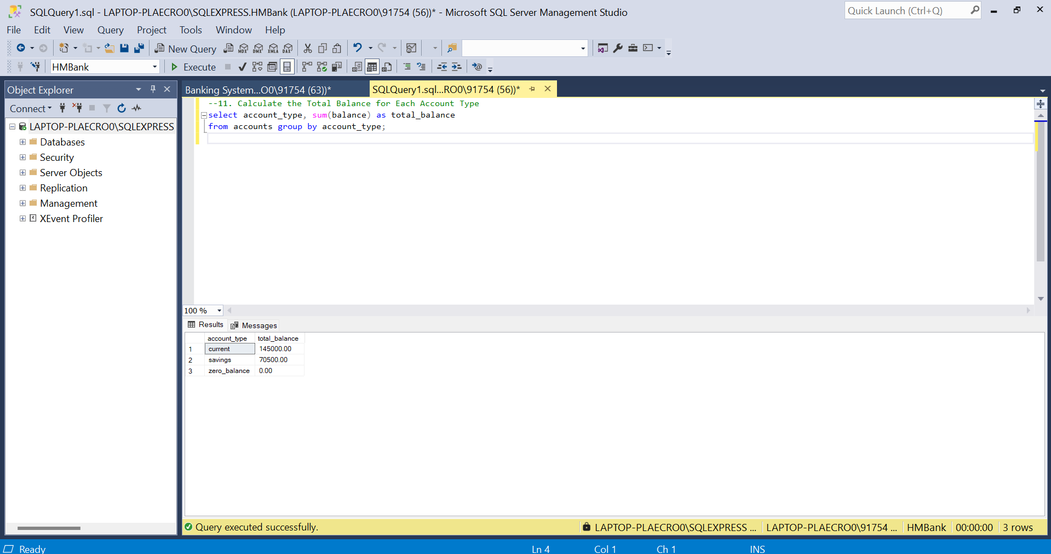

Q12. Identify Accounts with the Highest Number of Transactions (Descending Order)

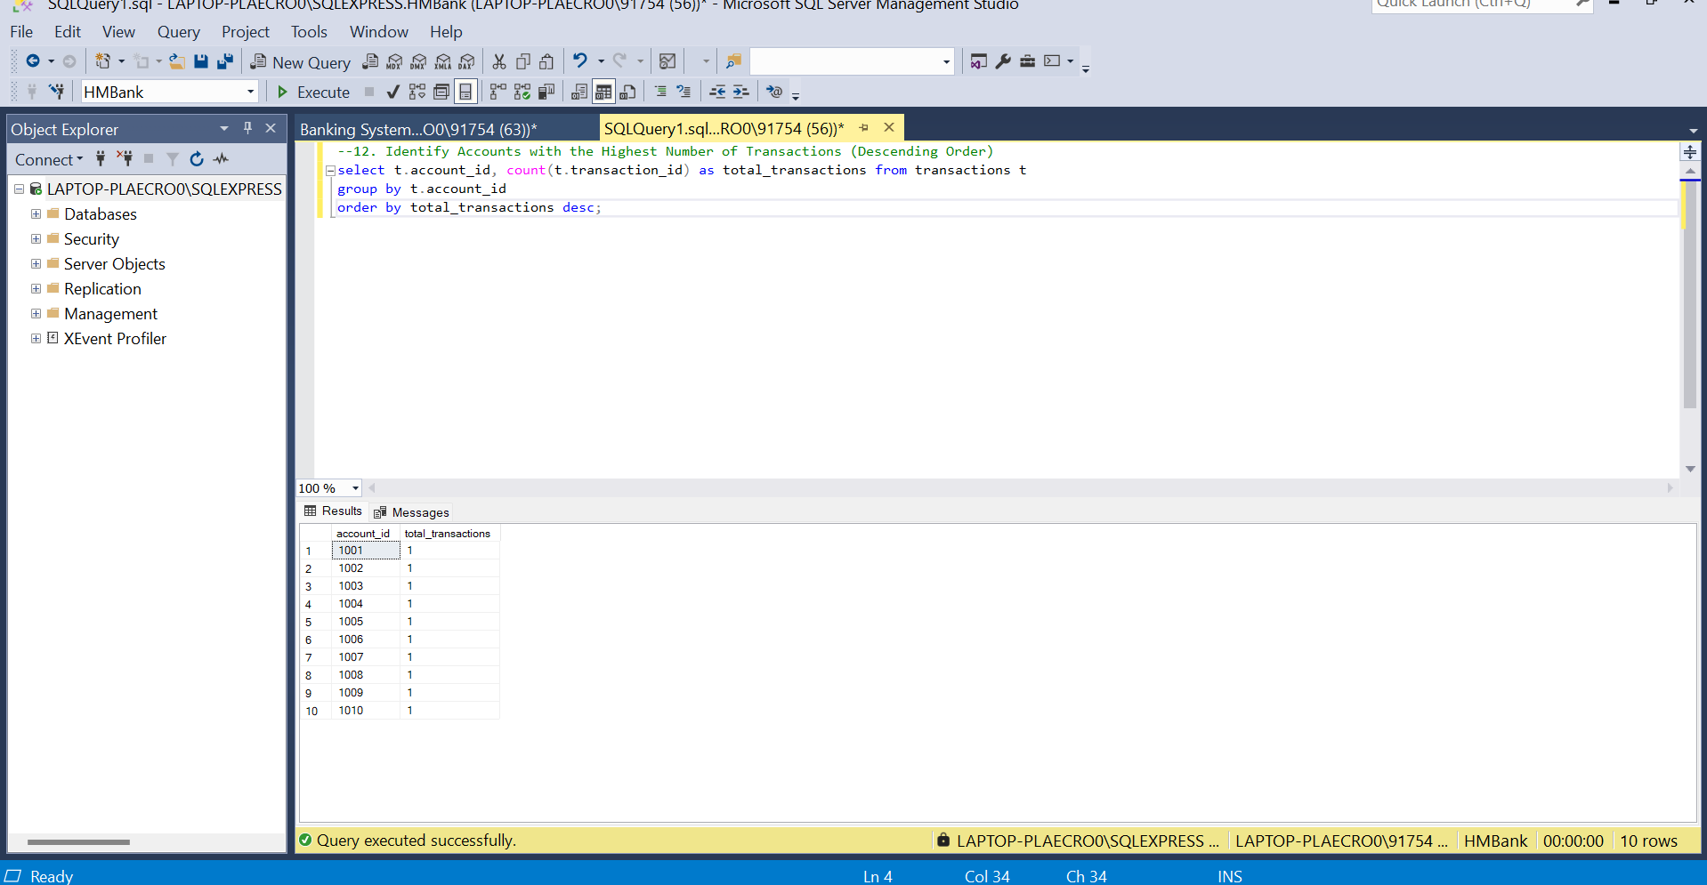

Q13. Customers with High Aggregate Account Balances Along with Their Account Types

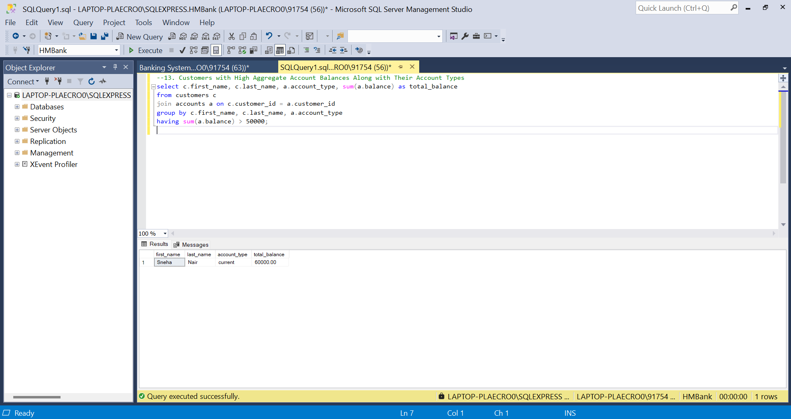

Q14. Identify and List Duplicate Transactions Based on Amount, Date, and Account

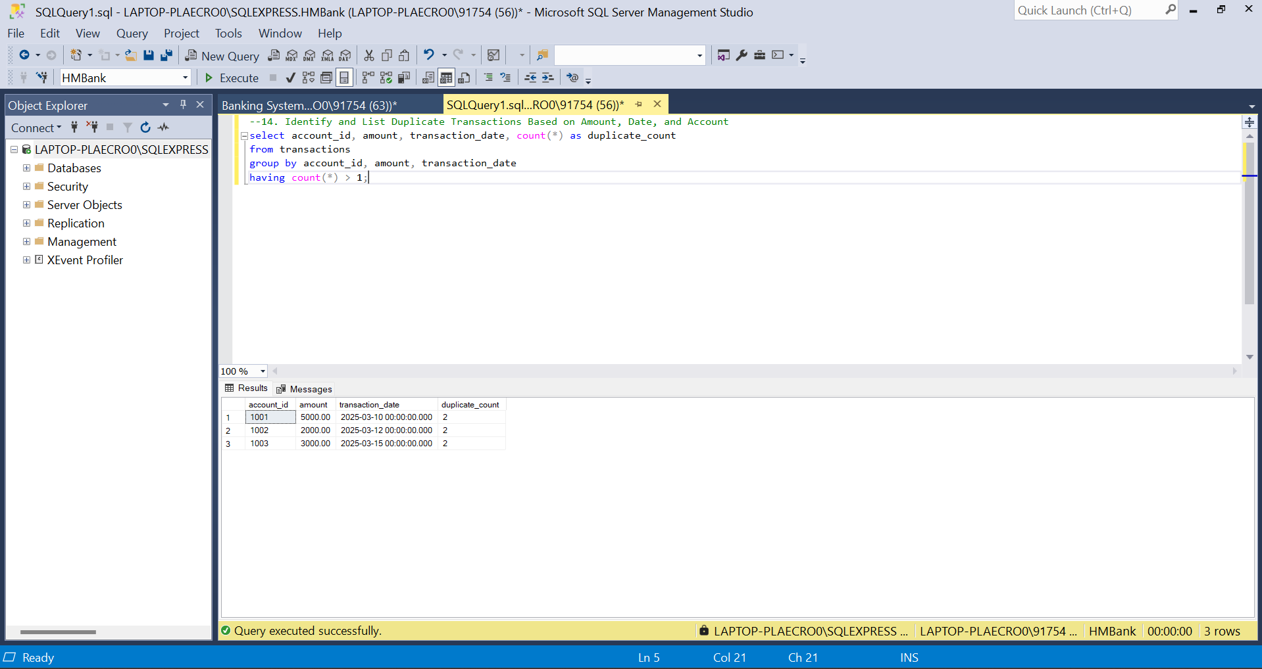

Tasks 4: Subquery and its type

Q1. Customers with the Highest Account Balance

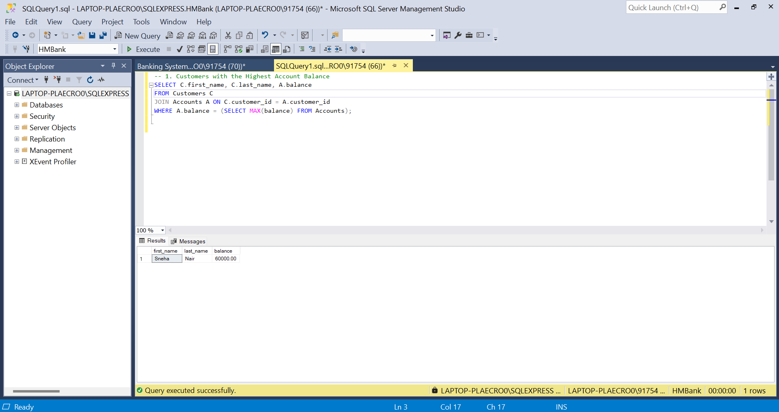

Q2. Average Account Balance for Customers with More Than One Account

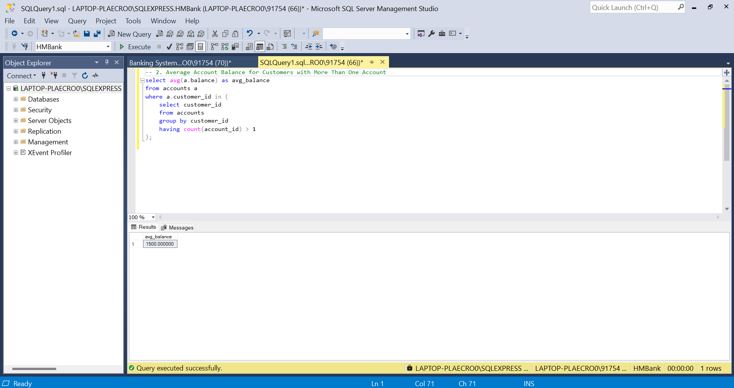

Q3. Accounts with Transactions Exceeding Average Transaction Amount

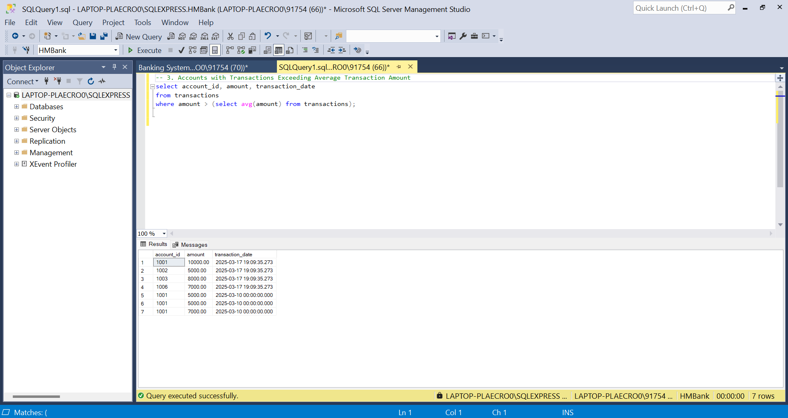

Q4. Customers Without Recorded Transactions

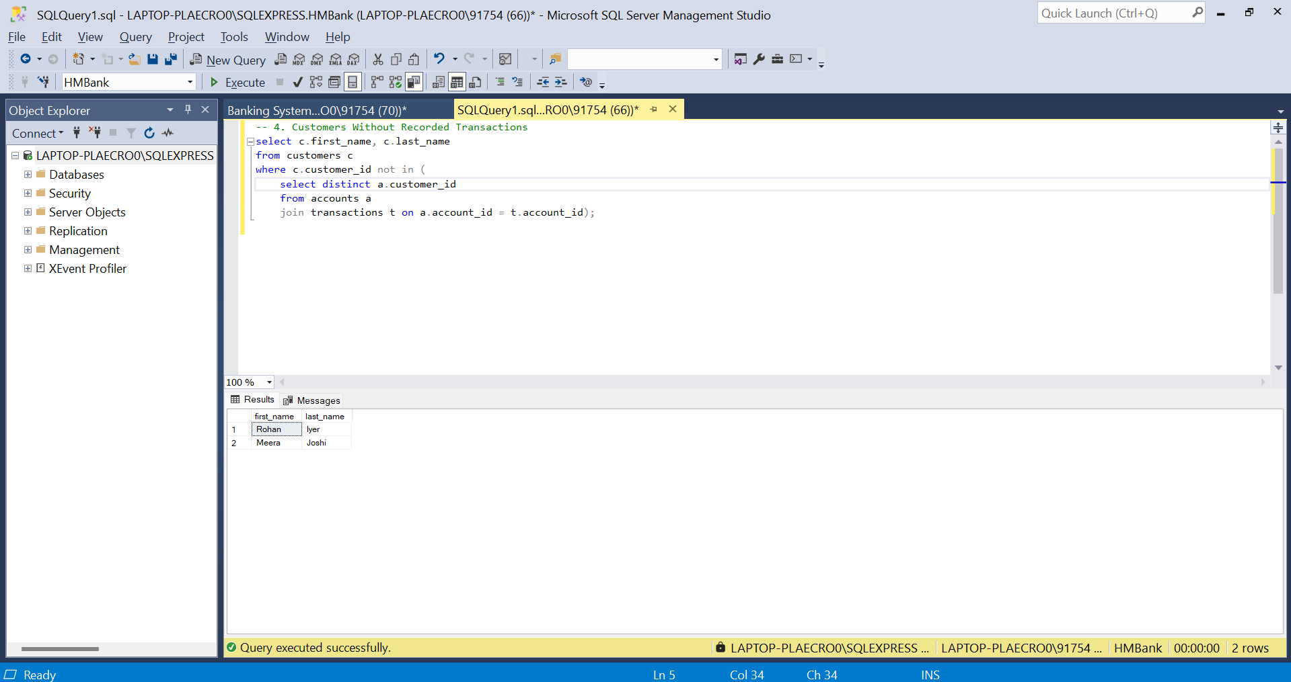

Q5. Total Balance of Accounts with No Recorded Transactions

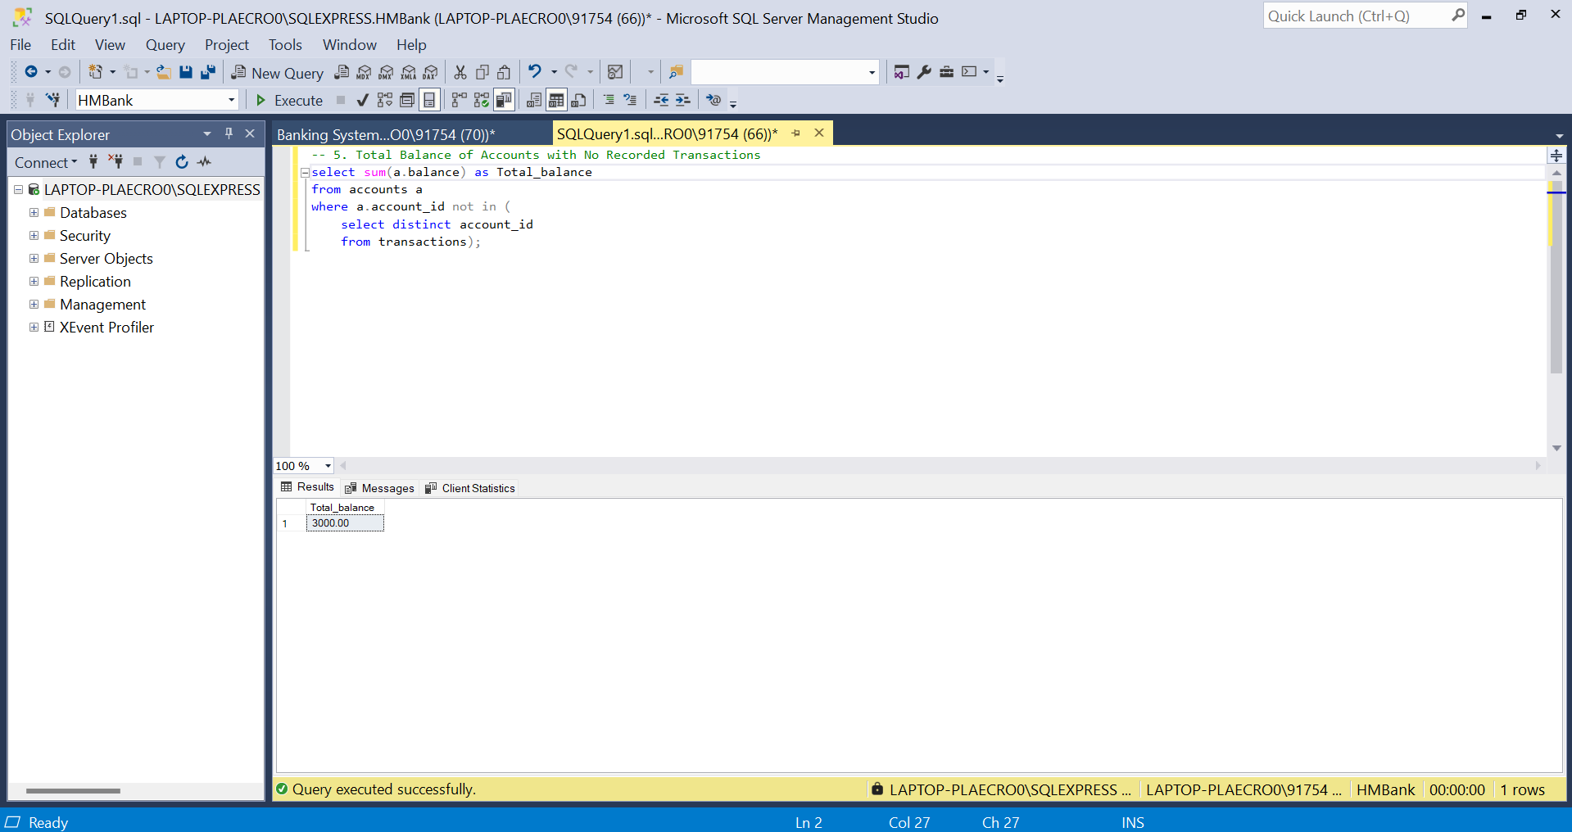

Q6. Transactions for Accounts with the Lowest Balance

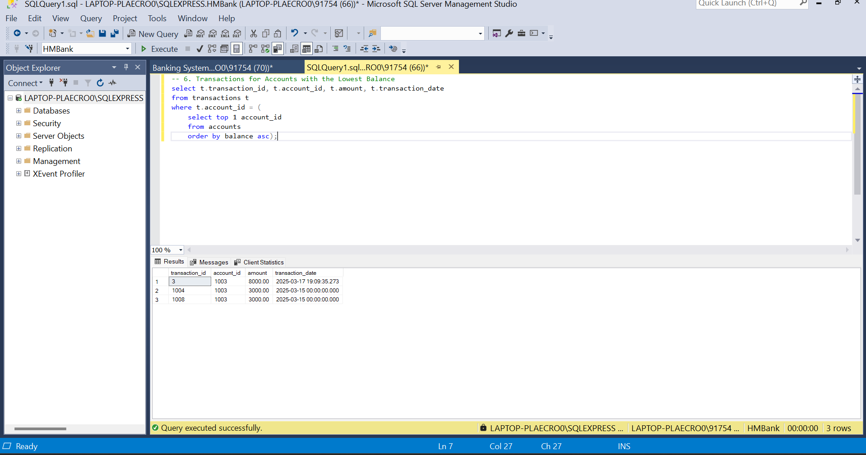

Q7. Customers with Multiple Account Types

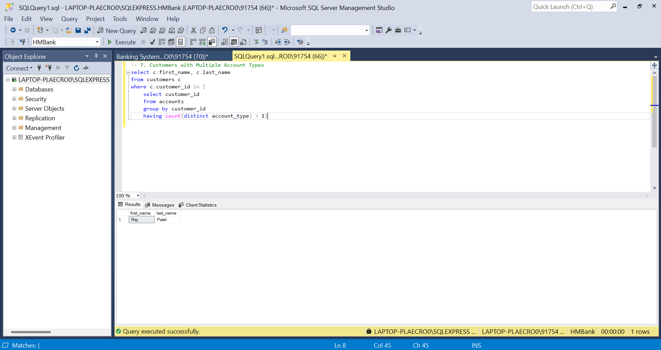

Q8. Percentage of Each Account Type

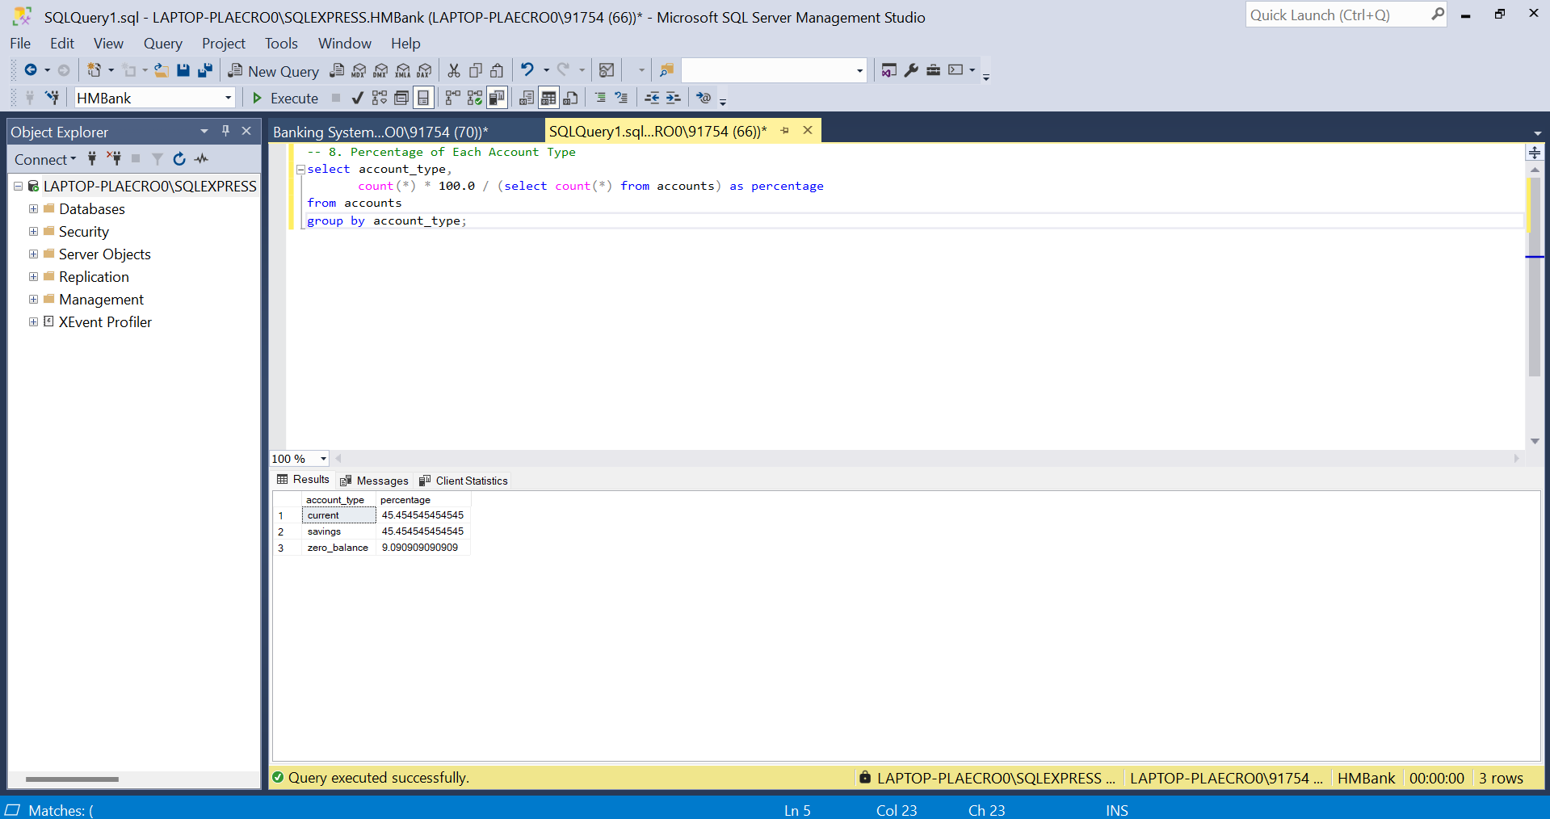

Q9. Transactions for a Given Customer ID

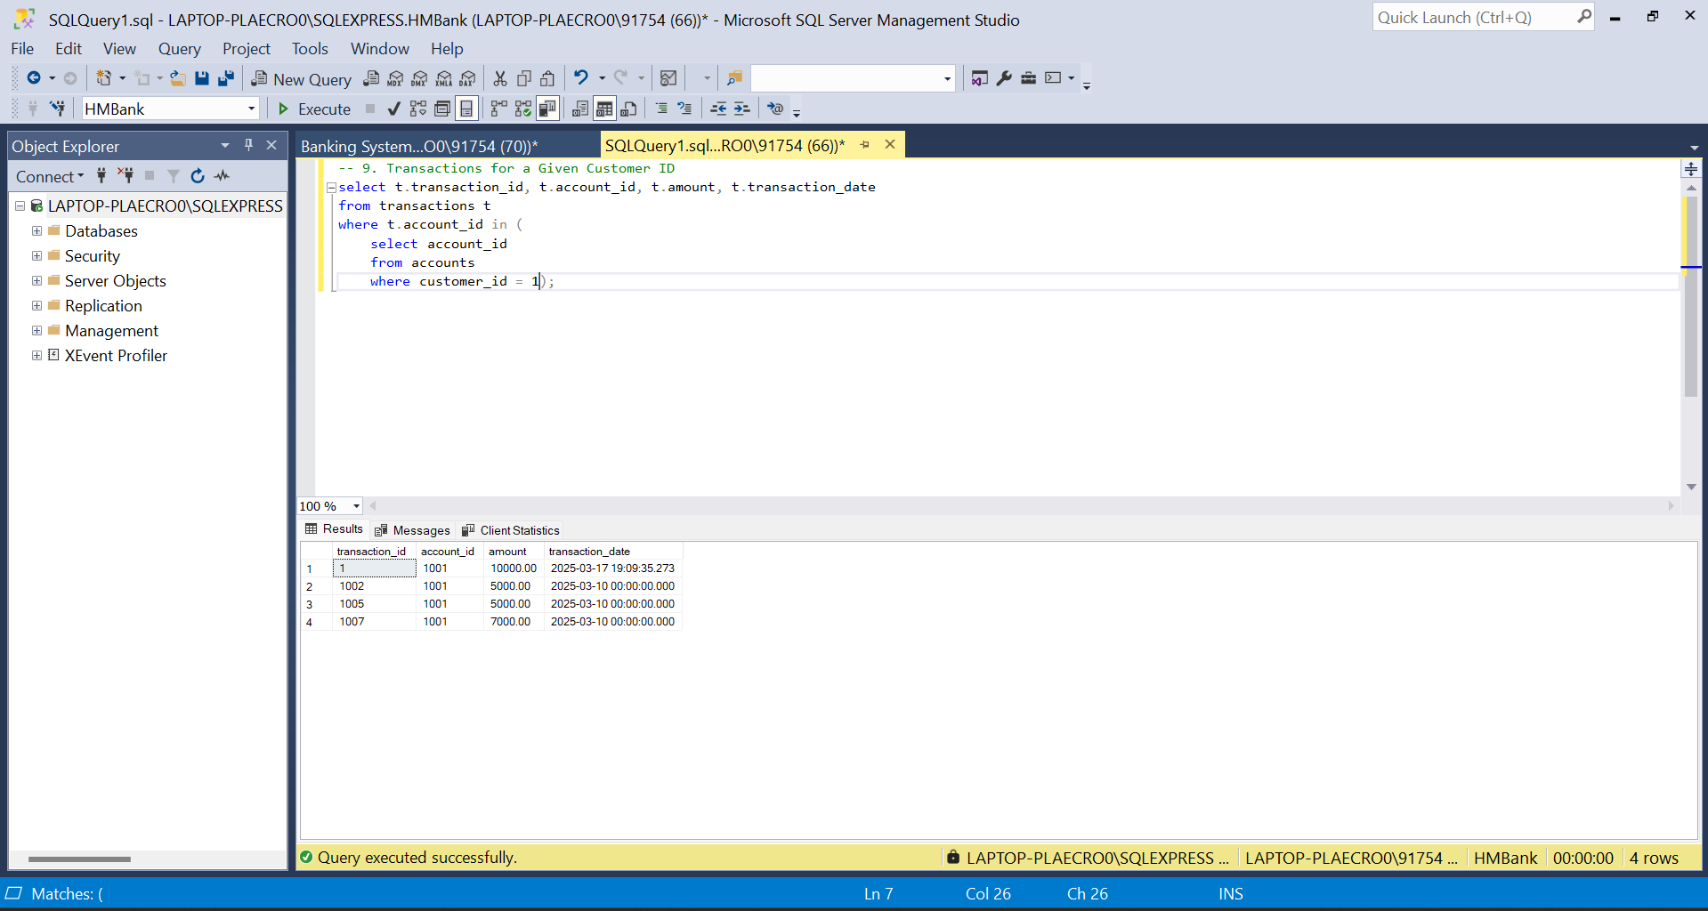

Q10. Total Balance for Each Account Type

